Lieutenant James Noel Nelson
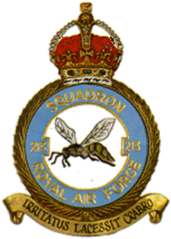
213 Squadron
Royal Naval Air Service
and Royal Air Force

Rank: Lieutenant
Date of Death: 14/06/1918
Age: 18
Regiment/Service: Royal Air Force, 213th Sqdn.
Grave Reference: 953.
Cemetery: HOOGSTADE BELGIAN MILITARY CEMETERY

Additional Information:
Son of Walter and Mary Hutcheson Nelson (nee Drinnan), of 15, Windsor Circus, Glasgow. Trained in Glasgow University O.T.C. and commissioned in R.N.A.S.

Died of wounds in air combat.

Country: Belgium
Locality: West-Vlaanderen
Identified Casualties: 20

Location Information
The village of Hoogstade is located south of the town of Veurne on the N8, which runs between Veurne and Ieper. Driving north from Ieper pass the crossroads for the junction with the N364 and Hoogstade is the next village. Take the first turning on the left into Brouwerijstraat and the cemetery is on your left. The graves are mixed in with the Belgian graves.

Historical Information
Scattered among the Belgian war graves in this cemetery are 20 Commonwealth burials of the First World War.

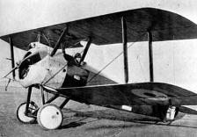
213 Squadron Information
No 213 Squadron was formed on 1 April 1918 at Bergues, from No 13 (Naval) Squadron RNAS. This RNAS squadron was itself formed on 15 January 1918 from the Seaplane Defence Flight which, since its creation in June 1917, had had the task of defending the seaplanes which flew out of Dunkirk. The squadron flew at that time Sopwith Camels, mounting fighter patrols and escorting bombers and reconnaissance aircraft from the Dunkirk airfields, based at Bergues in Flanders. The squadron derived its Hornet and motto for the squadron badge, after overhearing a Belgian general refer to the squadron's defence of his trenches, "Like angry hornets attacking the enemy aircraft." The squadron returned to the UK in March 1919 and was disbanded on 31 December 1919.

SQUADRON MOTTO
Irritatus lacessit crabro - 'The hornet attacks when roused'

