Second Lieutenant
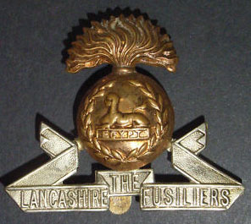
Lancashire Fusiliers
Cap Badge
Charles Drinnan Roberton
4th Battalion Lancashire Fusiliers

Rank: Second Lieutenant
Date of Death: 01/07/1916
Age: 23
Regiment/Service: Lancashire Fusiliers, 4th Bn.
Grave Reference: V. E. 10.
Cemetery: EUSTON ROAD CEMETERY, COLINCAMPS

Additional Information:
Son of Mrs. J. R. Roberton, of 31, Elgin Terrace, Dowanhill, Glasgow, and the late Mr. C. G. Roberton, O.B.E., of Barrow in Furness.

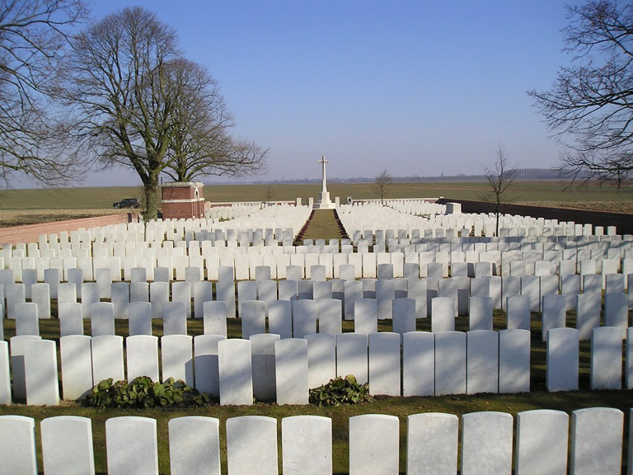
Euston Road Cemetery, Colincamps, Somme, France

Country: France
Locality: Somme
Identified Casualties: 1123

Location Information
Colincamps is a village 11 kilometres north of Albert. From Arras take the D919 in the direction of Amiens for 28 kilometres. The cemetery is situated about 1 kilometre from the D919 on the right hand side of the road. Pass Serre Road Cemetery No.2 and continue for 2 kilometres. Take the first right, and the CWGC direction sign to Euston Road Cemetery will be seen at the next Y junction.

Historical Information
Colincamps and "Euston", a road junction a little east of the village, were within the Allied lines before the Somme offensive of July 1916. The cemetery was started as a front line burial ground during and after the unsuccessful attack on Serre on 1 July, but after the German withdrawal to the Hindenburg Line in March 1917 it was scarcely used. It was briefly in German hands towards the end of March 1918, when it marked the limit of the German advance, but the line was held and pushed forward by the New Zealand Division allowing the cemetery to be used again for burials in April and May 1918.
The cemetery is particularly associated with three dates and engagements; the attack on Serre on 1 July 1916; the capture of Beaumont-Hamel on 13 November 1916; and the German attack on the 3rd New Zealand (Rifle) Brigade trenches before Colincamps on 5 April 1918.
The whole of Plot I, except five graves in the last row, represents the original cemetery of 501 graves. After the Armistice, more than 750 graves were brought in from small cemeteries in the neighbouring communes and the battlefields.
The cemetery now contains 1,293 Commonwealth burials and commemorations of the First World War. 170 of the burials are unidentified but there are special memorials to 32 casualties known or believed to be buried among them, and to two soldiers whose graves in nearby small cemeteries were destroyed in later battles.
The cemetery was designed by Sir Reginald Blomfield.

