Trades House of Glasgow
The Story of
Deacon Convener Francis Crawfurd
And
George Crawfurd Clerk to the Trades House

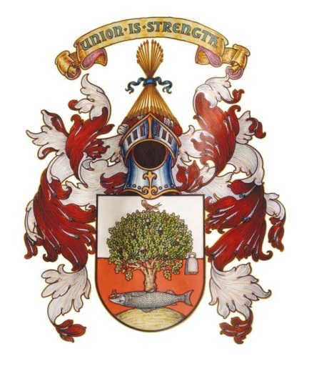

By
Craig R Bryce
Trades House Honorary Archivist

MMXX

Deacon Convener Francis Crawfurd
The family lineage is believed to descend from the Crawfurds of Jordan Hill.
James Crawfurd, of Glasgow (son of William Crawfurd), married Robina, Daughter of Francis Stevenson, and was buried at Glasgow, in the High Church Yard on 16th July 1713 leaving a son called Francis Crawfurd. Francis was Deacon Convener when he died away of a fever in his year of office on 30th November 1765 at the age of 61 years. He was baptised on 20th August 1706 and by calculating his date of death and birth, it would mean that he died about 59 years of age and not as is shown on his death certificate.
Francis’s Burgess ticket is dated 1st September 1732 and he was the eldest legitimate son of the deceased James Crawfurd. Francis’s father, James Crawfurd was the son of John Crawfurd of Crawfurdland B., both received their Burgess Tickets for free on the 19th August 1707.
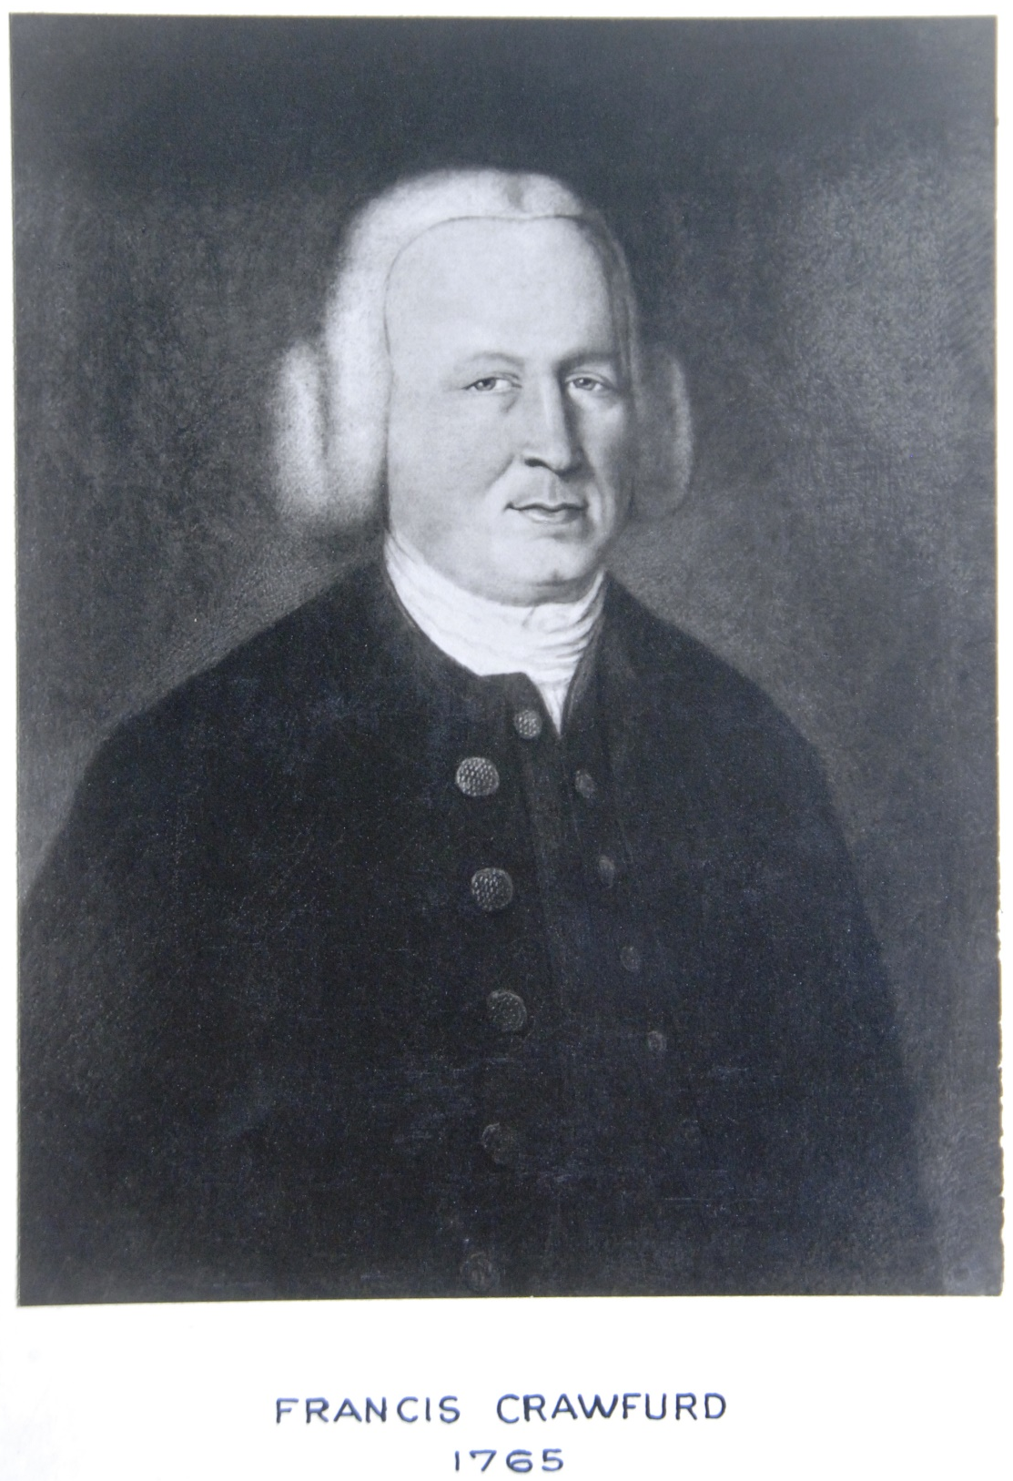
Francis Crawfurd about 1765
Francis carried the colours of the Glasgow Volunteers, when fighting against Prince Charles Edward Stewart at Falkirk, in 1745. The Glasgow Volunteers were badly handled by the Highland host during this conflict. He was Deacon of the Incorporation of Wrights from 1741 to 1742. Francis married Johanna Davis at St. Marylebone Church in London on 22nd June 1729. His first wife Johanna died on 10th June 1742. Francis and Johanna Davies had three children:
- Robert Baptised 13th January 1751 Married 30th November 1751
- Johana Born 30th January 1740 Baptised 1st February 1740
- Grisall Born 30th January 1740 Baptised 1st February 1740
He married his second wife, Christian Allison, at Rutherglen on 13th December 1742 and she passed away on 3 August 1745. At present no children have been found from this marriage. He married his third wife Jean Semple, the daughter of John Semple of Dalmock, Co., Dunbarton on 4th August 1746. Francis had the following children by his third wife Jean:
- John Born 19th August 1748
- James Born 3rd May 1754 Died in the West Indies
- Richard Born 22 April 1755 Died in the West Indies
- George Born 21st August 1756 Died 3rd April 1830
- Anne Born 9th October 1757
Francis and Jean’s younger son; George married Janet, daughter of Robert McClintock on 17th April 1780 and she died on 30th April 1822 and was buried in the Glasgow High Church Yard. George Crawfurd was Clerk to the Incorporation of Wrights from 1786 to 1822 and from 1822 to 1831, he was Clerk to the Trades House of Glasgow. A distinction that his son George would follow.
George and Janet had the following children:
- Robert of London Born 14th May 1782 Died 1836
- George Born 22nd March 1796 Married 27th November 1838
- William Craig Born April 1799 Died at Martinique 3rd Nov 1816
- Agnes Born 2oth June 1784 Married 17th April 1810
- Jessie Born 16th June 1792 Died 3rd February 1848
- Rabina Born 20th Oct 1794 21st December 1794
- Elizabeth Born 21 January 1798 Died 1818
- Christian Born 15th December 1801 Died 1864
- Francis Born 17th June 1801 Died 1837

George Crawfurd
Clerk of the Trades House of Glasgow
George Crawfurd’s birth certificate shows his name as Crawford and it seems this changed to Crawfurd after he started work with the Trades House. George was born on 22nd March 1796 his father was George Crawford a writer in Glasgow and Janet McClintock. The witnesses were Robert McClintock and James Forrester.
He was the clerk of the Trades House from 1831 to 1875 on his death. By the information in his death certificate, he was not in a working state for two years prior to his death. Sadly George’s memory and health were failing and George died on the 24th March 1875 at 8.30am aged 79 at his home, Thornwood. He was the widower of Agnes Wilkie. The cause of death was general paralysis which he suffered with for two years. George appeared to have been a well-liked clerk and was elected annually by the members of the Trades House and wrote the “A Sketch or the Rise and Progress of the Trades House of Glasgow, its Constitution, funds and Bye Laws” which was in use long after his demise.
George Crawford, of Thornwood, Bothwell was a Justice of the Peace, Clerk of the Peace for the County of Lanark and Clerk to the Grocer Company of Glasgow. George had an interest in politics and was a member of the Whig party of the Earl Grey School. On the establishment of the Volunteer Force in about 1860, George took a great interest in the resurrection of the Old Glasgow Guard and became a Lieutenant under Mr Walter Buchanan M.P. for the city who was Captain.
George married Agnes Gibson Wilkie from Bothwell who was the lawful daughter of the deceased General James Wilkie, late of Knowhead, Uddingston on 27th November 1838. George was a writer Glasgow and the service was conducted by a Mr James Thomson. They had the following children:
- George of Glasgow Born 30th May 1841 Died 1891
- James Born 18th February 1846
- Francis of Helensburgh Born 22nd April 1847
- Agnes Married 26 August 1879
- Jessie Died 1st August 1885

The 1851 Census shows George and Agnes Crawfurd had five children:
George Crawford aged 9 tears and a scholar
Agnes Crawford aged 8 years and a scholar at home.
Jessie Crawford aged 6 years and a scholar at home
James Crawford aged 5 years and a scholar at home
Frances Crawford aged 3 years and a scholar at home
The 1861 census shows the same people living in Thornwood with the addition of Robina, George Crawford’s 66 year old sister who was a propriotress of houses.
The Glasgow Herald of 25th March 1875
Agnes died on 17th September 1864 at 4.45 am in Thornwood House aged 47 years. She died of an epileptic convulsion after four days.
Agnes’s father was called James Wilkie and her mother’s name was Agnes Gibson.
George Crawfurd’s addresses can be found in the Street Directories of Glasgow and he lived or worked at the following locations:
1814 ~ Crawford, George, writer, 46, High Street ; house, 62, Montrose Street
1825 ~ Crawfurd, Geo. writer, 16, Virginia street; house 5, York Street
1835 ~ Crawford, George, writer, 93 Glassford Street, house 64 Regent Street
1849 ~ Crawford, George, writer, 33 West George Street
1866 ~ Crawfurd, George, writer and clerk of the peace, 111 Brunswick Street; ho. Thornwood house, Bothwell.
1873 ~ Crawfurd, George, writer, and clerk of the peace, 72 Hutcheson Street ; res. Thornwood house, Bothwell.
George Crawfurd’s second son, James Crawfurd of Thornwood in the County of Lanark was a J.P. like his father and he also held a B.A. from Trinity College, Dublin and he was a Barrister-at-law of the Inner Temple, he was formerly in the Bengal Civil Service and Judge of Hooghley in 1891.
On the right-hand side of the stairwell in the Trades House hangs George Crawfurds portrait
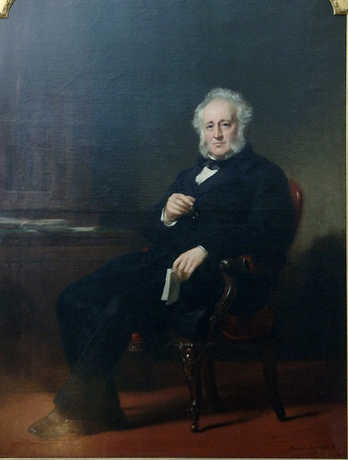
George Crawfurd
© Trades House
Clerk to the Trades House, George Crawfurd 1831 - 1875
In November 1866, the Trades House received a proposal from Mr Ledingham, seconded by Mr Graham the meeting unanimously resolved that the House should contribute a sum not exceeding fifty pounds towards the sum necessary along with the sums already subscribed by the several Incorporations, to obtain a portrait by Mr Daniel McNee of Mr Crawfurd in consideration of his having satisfactorily discharged the duties of Clerk to the House for nearly thirty six years.
The portrait of George Crawfurd was offered on permanent loan by the Royal Scottish Academy and gratefully accepted by the Trades House.,
It was George Crawfurd who wrote the famous “A Sketch or the Rise and Progress of the Trades House of Glasgow, its Constitution, funds and Bye Laws” and which was printed in 1858. This well-known book is still referred to even though it is not always truly accurate. It is worth noting George’s pince-nez glasses in his right hand and the book in his left hand, both are indicators of his employment.
Artist: Sir Daniel Mcnee. 1866

www.scotlandspeople.gov 30/11/1765 Crawfurd, Francis (Old Parish Registers Deaths 644/500 98 Glasgow) Page 98 of 370.
www.ancestry.co.uk 1860 Burkes Family Records (Indexed)
James R Anderson, Scottish Record Society, The Burgess & Guild Brethren of Glasgow 1751-1846.
James R Anderson, Scottish Record Society, The Burgess & Guild Brethren of Glasgow 1573-1750.
www.ancestry.co.uk 1860 Burkes Family Records (Indexed)
www.ancestry.co.uk
www.ancestry.co.uk 1860 Burkes Family Records (Indexed)
www.scotlandspeople.gov.uk 22/03/1796 George Crawford (Old Parish Registers Births 644/1 190 270) Page 270 of 460
www.tradeshouselibrary.org Clerks to the Trades House
www.scotlandspeople.gov.uk 1875 George Crawfurd (Statutory Register Deaths 625/1 71)
Glasgow Herald, 25th March 1875.
www.scotlandspeople.gov.uk 27/11/1838 Agnes Gibson Wilkie (Old Parish Registers Marriages 644/1 420 201 Glasgow) Page 201 of 798
www.ancestry.co.uk 1860 Burkes Family Records (Indexed)
www.scotlandspeople.gov.uk 1851 George Crawfurd (Census 625/5 19) Page 19 of 24
www.scotlandspeople.gov.uk 1861 George Crawfurd (Census 625/1 4 25) Page 25 of 27
www.scotlandspeople.gov.uk 1862 Agnes Crawfurd (Statutory Register Deaths 625/1 109)
www.ancestry.co.uk
www.ancestry.co.uk 1860 Burkes Family Records (Indexed)
Minutes of the Trades House of Glasgow, 22nd November 1866.
Minutes of the Platform Committee, 9th May 1984.
Minutes of the Building Committee, 24th September 1986.

