Trades House of Glasgow
James Buchanan and
Jane Buchanan (nee Jack)

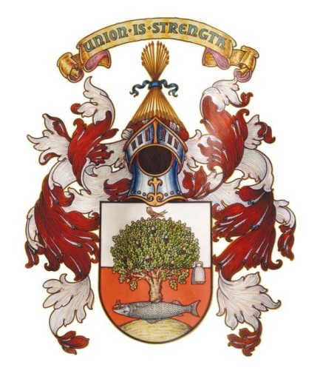

By

Craig R Bryce
Trades House Honorary Archivist

MMXX

James Buchanan’s Biography
James Buchanan was born on 27th June 1784, his father was Alexander Buchanan and his mother was called Jean Robertson. He started off life as a blacksmith in Glasgow before moving into merchandising and having interests in Jamaica. In 1800 he moved to St George’s, Grenada in the West Indies in connection with the firm of Dennistoun, Buchanan, and Co, of which house he afterwards became a partner. Here he made a large fortune, and afterwards came home to Scotland, where he resided for a long period in retirement.
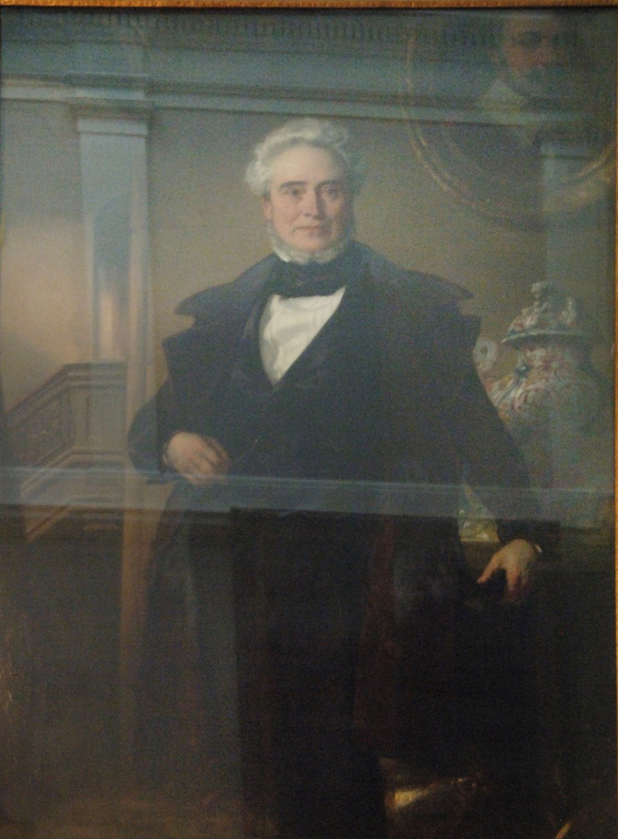
James Buchanan
© Trades House of Glasgow

There is no record that James Buchanan ever owned slaves himself, although his role would have involved profiteering from commerce related to chattel slavery. As a junior worker in Grenada, his role might have included managing the store and conducting business with resident slave plantation owners and managers (as well as supervising any enslaved workers connected with the store). After a seven-year training period under a Mr Wilson in Grenada, James Buchanan became the firm’s managing partner in Kingston, Jamaica and Rio De Janeiro, Brazil (both also slave owning societies). In a more senior commercial role, he might have been responsible for financial business including the management of a firm’s activities including the loaning of mortgages to resident slave-owners. After his return to Scotland in 1816, Dennistoun, Buchanan & Co.’s minute books confirm he was still involved in the company’s trading activities as late as October 1825.

James married Jane Jack of Gorbals, Glasgow on 16th July 1817. He was recorded as ‘of Buenos Ayres’.

James Buchanan subsequently accumulated a major portfolio of shares and investments in commerce and industry, including in Scottish and English railways and American banks and insurance companies. He also acquired urban property in Glasgow and a luxurious home in 47 Moray Place in Edinburgh’s New Town. Upon his death on 21st December 1857, Buchanan had a personal fortune of over £124,000 (and more in heritable property). Buchanan had spent sixteen years in the West Indies (seven in Grenada, nine in Jamaica and Brazil), and then about forty-two years in Edinburgh investing the money he had made in commerce, land and industry across Scotland, England and America. His wealth at the time of his death was therefore derived from multiple sources. At the very least, however, the initial accumulation of capital was probably acquired in the West Indies and Brazil (although there are no extant records documenting how much wealth he accumulated during these years) which facilitated later profitable investments, some of which became the Ewing/Buchanan bequest approximately fifty-two years after his death.

Jane Buchanan
Jane Buchanan was born about 1798. She had outlived her husband by 26 years when she died at home at 49 Moray Place, Edinburgh, of Gastric Catarrh and Biliary Colic, on 11th June 1883 and she was 85 years old. She had contributed liberally towards the construction and support of drinking troughs for animals in London and elsewhere, and founded and supported a school in Swatow in China, in which 20 girls received a Christian education. In 1880 she presented £1000 to the University of Edinburgh for the foundation of a scholarship in midwifery and gynaecology.
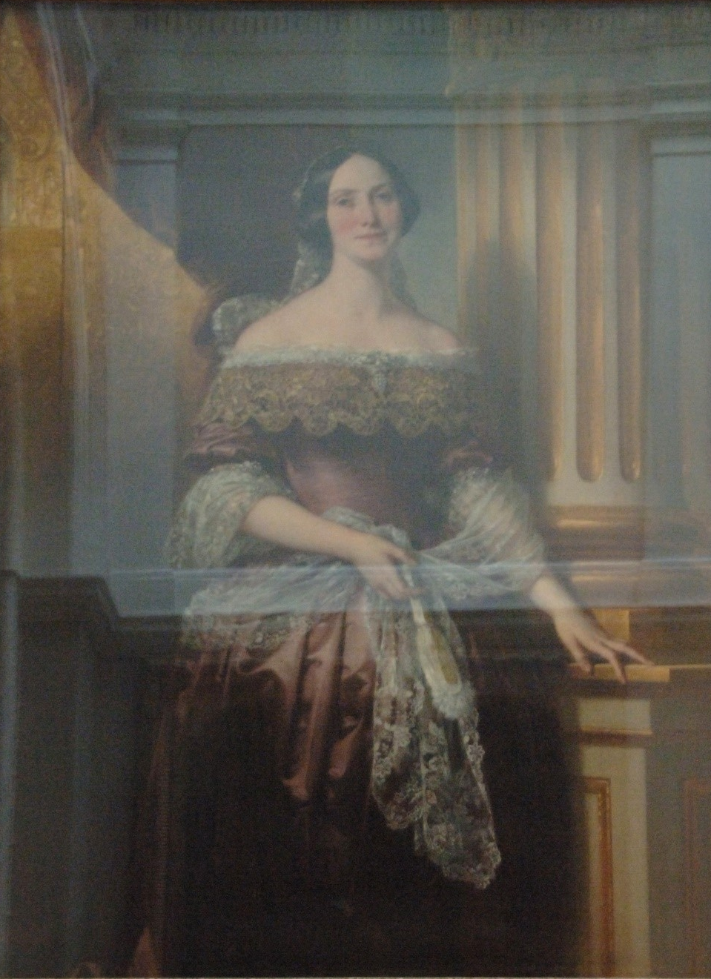
Jane Buchanan (Nee Jack)
© Trades House of Glasgow

She was a regular worshipper at Cuthbert's Church in Edinburgh. Her remains were laid beside the mausoleum in the Dean Cemetery, which she had erected to the memory of her husband.

James Buchanan’s Monument Repair and Restoration
Sadly Mrs Buchanan did not leave any money for the upkeep of this mausoleum, and in February 1913 it was in need of repair. This was brought to the attention of the Trades House and the Merchants House by the Buchanan Trust as both had gained from £10,000 being left to both institutions. The Buchanan Trust were unable to assist in the payment of the repairs due to the scheme under which they had been set up. The Trades House agreed to pay £5 towards the repair on condition that the Merchants House did the same. The cost of the repair was £10. On 6th May 1913, the House met once again, and the Convener reported that the Late James Buchanan’s Monument would cost more than had been reported at the last meeting. Mr. Ninian McWhannell, Architect, had visited the Cemetery and had made a minute inspection of the Monument. He was of opinion that the cost of repair would probably amount to £25 or £30. It was agreed that the House would pay half if the Merchant’s House would pay the other half.

Three years later the saga of the Buchanan Monument had still not been resolved and a letter was sent from the Merchants House concerning the poor state of the monument. It outlined the following facts:

- Sir Thomas Mason had made a careful examination of the Monument and it was his view that it would cost about £150 to make a really satisfactory repair.
- The expenditure of £30 (which was the figure suggested before) would be quite ineffectual.
- He also reported that the stone which the monument was made from, had not stood well and even if the repair is carried out, it will require future repairs from time to time.
- It was also noted that the Monument stood on an unusually large piece of ground and that Mrs Buchanan is buried in a portion of it, but it was otherwise unoccupied.
- Sir Thomas suggested that this ground was now very valuable and by selling some of it to the Cemetery Company, a fund could be set up to pay for the present repairs and also provision could be made for future repairs.

It was agreed to remit the whole question to the Finance Committee.

In September 1916 another letter had been received from the Merchants House suggesting that a Committee should be appointed to consult with the Merchants House and the Governors of the Buchanan Institution to consider proposals for having the Monument repaired. The House met again on 7th November 1916 and the Platform reported that they had met with the Merchants House and the Buchanan Institution where Sir Thomas Mason reported that the cost of restoration would not fall short of £500. The House unanimously agreed to pay half on the understanding that the Merchants House would pay the other half.

At a meeting of the House on 1st October 1917, it was reported that, acting in cooperation with Sir Thomas Mason, the repairs and renovation to James Buchanan’s Monument were complete. Particular attention had been paid to the bust and marble panel on the front of the vault and the sculptor had been successful in retaining the good lines designed by the original artist. The total cost amounted to £125 15s., which would be paid equally by the Trades House and the Merchants House. The key of the small gate to the Monument was in the possession of Late Collector Jackson Millar.

In May 1931, the Trades House received a letter from the Session Clerk of Glasgow Cathedral regarding a stained-glass window erected to the memory of Mr. and Mrs. James Buchanan in the Cathedral. The Kirk Session wished to remove the Buchanan window which was not in a good state of repair and to replace it with one to the memory of a Glasgow gentleman who had left a sum of money for that purpose and it would take the place of the one erected to Mr. and Mrs Buchanan. In May 1931, the Finance Committee met once again and discussed the question of the Buchanan Memorial Window in the Cathedral. The Clerk had ascertained that the window had been erected by Mrs James Buchanan, but no funds had been left by her for its maintenance. It was agreed that the Trades House would write, indicating that they deprecate the removal of the window but they did not propose to raise any objection provided an inscription indicating that the new window takes the place of that erected to the memory of Mr. Buchanan appears on the new window, and not merely on a tablet affixed beneath it. It took the Cathedral a good few years before they were ready to act on the Buchanan Memorial Window in the Cathedral when in January 1936, the Platform considered a letter from the Session Clerk which indicated that the Window was in a poor state of repair and that they wished to put up a window to the memory of the Mowatt family. The proposal was agreed to if a suitable inscription was put at the bottom of the window.

One of James Buchanan’s best-known legacies was as the founder of the Buchanan Institution (established in 1859) in the former Greenhead House at 47 Greenhead Street in Bridgeton, to provide education and industrial training for the city's destitute boys. It later became Greenview Special School. His and his wife’s paintings still hang in the Trades Hall, but the lower portions were cut off as the paintings were too large.

Mr. James Buchanan, by a Codicil to his Settlement, dated 17th May, 1857, bequeathed £10,000 to the Trades' House in the following terms:- "To invest £10,000 twelve months after Mrs. Buchanan's death, in name of the Trades' House of Glasgow in trust for educational purposes, on behalf of the sons of decayed Members of that House. The dividends to be exclusively expended towards the education of the sons of decayed Members, and also for promoting the studies of such of them as give decided promise of mechanical genius, particularly in the department of engineering, in such manner as the Directors of the House may deem best."

In April 1885 the Education Committee formed a Sub-Committee to consider Scholarships and to report on the Buchanan Bequest as it had become operable This Scholarship was a great boon to many young men and women who wished to further education and countless scholars gained from his generous benevolence. The remains of James Buchanan’s legacy which is still managed by the Trades House of Glasgow, continues to help students and apprentices for educational purposes today.

Buchanan Street in Glasgow is not named after this James Buchanan but is named after an Andrew Buchanan.

National Records of Scotland, 27/06/1784 James Buchanan (O.P.R. Births 644/1 333 Glasgow) Page 333 of 470.
British Newspaper Archive, York Herald, Saturday 09 January 1858, p 11.
British Newspaper Archive, York Herald, Saturday 09 January 1858, p 11.
www.scotlandspeople.org, 16/07/1817, Jane Jack (O.P.R. Marriages 644/2 30 186 Gorbals) Page 186 of 216.
www.scotlandspeople.org, 1857, James Buchanan (Statutory Records Deaths 685/1 518).
British Newspaper Archive, York Herald, Saturday 09 January 1858, p 11.
www.scotlandspeople.org, 1883, Jane Buchanan (Statutory Records Deaths 685/1 657).
British Newspaper Archive - Edinburgh Evening News - Wednesday 13 June 1883, p2.
Trades House, Finance Committee Minutes, 3rd February 1913.
Trades House, Finance Committee Minutes, 6th May 1913.
Trades House Committee, 31st May 1916.
Trades House Minutes, 26th September 1916.
Trades House Minutes, 7th November 1916.
Trades House Minutes, 1st October 1917.
Trades House, Finance Committee Minutes, 13th May 1931.
Trades House, Finance Committee Minutes, 31st July 1931.
Trades House, Platform Committee Minutes, 15th January 1936.
British Newspaper Archive - York Herald - Saturday 09 January 1858, p 11).
Trades House of Glasgow, Education Committee Minutes, 24th April 1885.

