Lieutenant Norman Fraser
Royal Navy Reserve

Rank: Lieutenant
Date of Death: 15/02/1918
Age: 27
Regiment/Service: Royal Naval Reserve, H.M. Drifter "Jeannie Murray."
Panel Reference: 30.
Memorial: PORTSMOUTH NAVAL MEMORIAL

Additional Information:
Son of James and Christina Sutherland Fraser of 42. Garturk St., Crosshill, Glasgow.

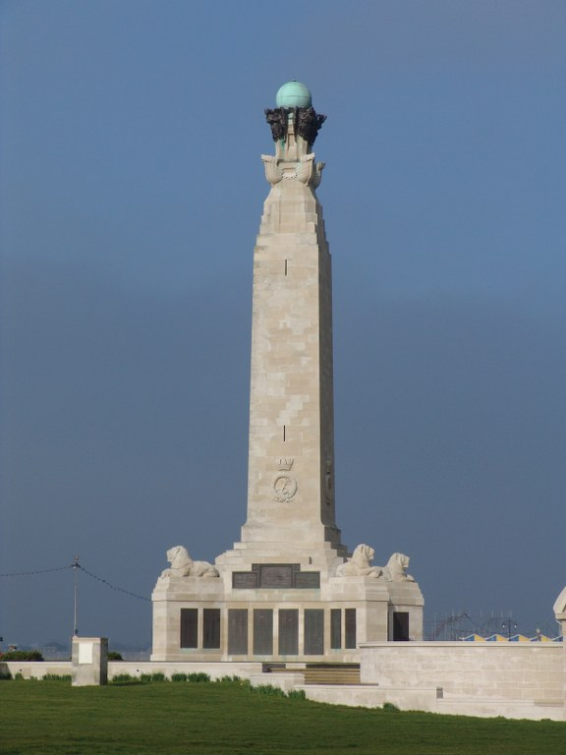
Portsmouth Naval Memorial, England
Country: United Kingdom
Locality: Hampshire
Identified Casualties: 24597

Location Information
The Memorial is situated on Southsea Common overlooking the promenade, and is accessible at all times. A copy of the Memorial Register is kept at the Civic Offices in Guildhall Square and may be consulted there.
http://www.memorials.inportsmouth.co.uk/southsea/naval.htm
Visiting Information
Visitor Information Panels have recently been installed at the Portsmouth Naval Memorial to provide information about the war casualties commemorated here. Panels are being erected to help raise awareness of First and Second World War casualties in the UK (Feb 2013) ** Disabled access to the World War 2 Section of the Memorial is possible via the Common and the ramps at the rear of the Memorial. For further information regarding disabled access, please contact our Enquiries Section on 01628 507200.

Historical Information
After the First World War, an appropriate way had to be found of commemorating those members of the Royal Navy who had no known grave, the majority of deaths having occurred at sea where no permanent memorial could be provided.
An Admiralty committee recommended that the three manning ports in Great Britain - Chatham, Plymouth and Portsmouth - should each have an identical memorial of unmistakable naval form, an obelisk, which would serve as a leading mark for shipping. The memorials were designed by Sir Robert Lorimer, who had already carried out a considerable amount of work for the Commission, with sculpture by Henry Poole. The Portsmouth Naval Memorial was unveiled by the Duke of York (the future George VI) on 15 October 1924.
After the Second World War it was decided that the naval memorials should be extended to provide space for commemorating the naval dead without graves of that war, but since the three sites were dissimilar, a different architectural treatment was required for each. The architect for the Second World War extension at Portsmouth was Sir Edward Maufe (who also designed the Air Forces memorial at Runnymede) and the additional sculpture was by Charles Wheeler, William McMillan, and Esmond Burton. The Extension was unveiled by the Queen Elizabeth, the Queen Mother on 29 April 1953.
Portsmouth Naval Memorial commemorates around 10,000 sailors of the First World War and almost 15,000 of the Second World War.

Details of H.M. Drifter Jeannie Murray
The JEANNIE MURRAY Banff reg: BF 623, was built in 1907, 90grt, she was armed with 1-3pdr AA gun, she was an Admiralty hired AA Steam Net Drifter

H.M. Drifter Jeannie Murray was one of eight vessels sunk in the Dover Straits in a surprise attack by a force of seven German Destroyers on the night of 14/15 February 1918. The hired trawlers and drifters sunk by the German attack were: CHRISTINA CRAIG, CLOVER BANK, COSMOS, JAMES POND, JEANNIE MURRAY, SILVER QUEEN, VERACITY, and W. ELLIOT - GOLDEN RULE and VIOLET MAY were damaged.

All fifteen crew of the JEANNIE MURRAY were killed in this one attack.

