Piper Archibald Nisbet
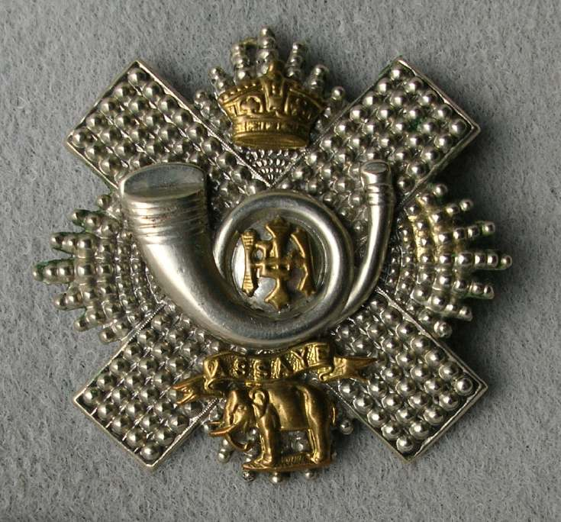
Highland Light Infantry
3rd Bn. Highland Light Infantry
Army No: 25257

Rank: Private
Service No: 25257
Date of Death: 13/01/1919
Age: 29
Regiment/Service: Highland Light Infantry, 3rd Bn.
Grave Reference: 1. 104.
Cemetery: NEWTOWNARDS (MOVILLA) CEMETERY

Additional Information:
Son of Mr. and Mrs. James Nisbet; husband of Jeannie Nisbet, of 25, Balfour St., Newtownards. Born at Galston, Ayr.

Archibald Nisbet enlisted on 13th November 1915 and was discharged due to sickness on 29th May 1916. He applied for and was issued with a Silver War Badge.

Country: United Kingdom
Locality: County Down
Identified Casualties: 38

Location Information
The cemetery is at Moviola Road, on the Donaghadee road, encloses the ruins of Movilla Abbey.

Historical Information
Newtownards is a town in the north-east of County Down, near the head of Lough Strangford. It is 14 kilometres by road from Belfast. Newtownards Camp was one of the four used by the 36th Division in 1914.
There are 21 Commonwealth burials of the 1914-1918 war. There are a further 24 of the 1939-1945 war, 7 of which are unidentified. There are also 3 Polish Foreign National burials here.

