Private Colin Campbell Stewart
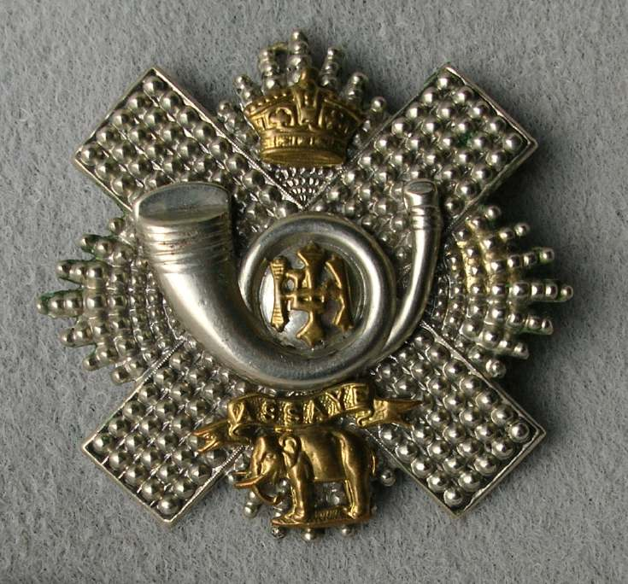HLI Cap Badge
17th Highland Light Infantry
Army No: 16269

Rank: Private
Service No: 16269
Date of Death: 01/07/1916
Age: 21
Regiment/Service: Highland Light Infantry, 17th Bn.
Grave Reference: IV. E. 2.
Cemetery: LONSDALE CEMETERY, AUTHUILLE
Additional Information:
Son of John and Jessie Stewart, of Ardsheal, Scotstounhill, Glasgow.

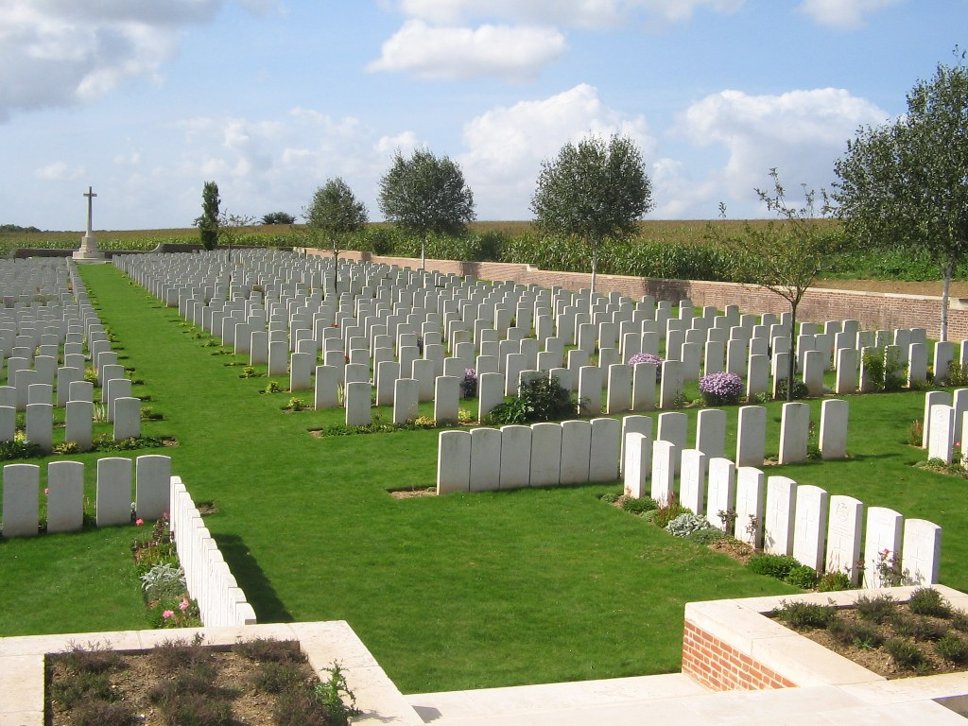
Lonsdale Cemetery, Authuille

Country: France
Locality: Somme
Identified Casualties: 726

Location Information
Authuille is a village 5 kilometres north of the town of Albert on the D151 road to Grandcourt. The Cemetery (signposted in the centre of Authille) is 1 kilometre east of the village. Access to the cemetery, 500 metres from the road, is by a grass pathway (unsuitable for cars).

Visiting Information
Visitors to Lonsdale Cemetery near Thiepval are advised that, due to the temporary lack of access path across the wheat field, access is extremely difficult especially in wet weather. The Commission is working with the local land owner to get an agreement to reinstate the access path as soon as possible but this is unlikely to be resolved until late spring 2013 at the earliest.
The Commissions gardeners are continuing to maintain the site despite the difficulty of access and can if required lay wreaths or take photographs on behalf of visitors who are not able to access the site themselves please contact France Area office for further details or to make arrangements.
There will be no access problems during the summer period.
The part of the access path we’re concerned about has been re-levelled & reseeded by the Thiepval team and up until this point there are no access problems, the neighbouring crops will be trimmed back as necessary to ensure safe access.
Wheelchair access to this cemetery is possible, but may be by an alternative entrance. For further information regarding wheelchair access, please contact our Enquiries Section on 01628 507200.

Historical Information
On 1 July 1916, the first day of the Battle of the Somme, the 32nd Division, which included the 1st Dorsets and the 11th (Lonsdale) Battalion of the Border Regt attacked the German line at this point and stormed the Leipzig Salient, but were compelled to retire later in the day. In the spring of 1917, after the German withdrawal to the Hindenburg Line, V Corps cleared these battlefields and made a number of new cemeteries, including Lonsdale No.1 and No.2.
Lonsdale Cemetery No.1 (the present Lonsdale Cemetery) contained originally 96 graves (now in Plot I), the great majority of which were those of officers and men of the 1st Dorsets and the 11th Borders. It was enlarged after the Armistice when graves, almost all of 1916, were brought in from the surrounding battlefields and from other small burial grounds, including:-
LONSDALE CEMETERY No.2, which was about 500 metres further East. It contained the graves of 38 soldiers from the United Kingdom (31 of whom belonged to the 11th Borders) and two German soldiers.
NAB ROAD CEMETERY, Ovillers-la-Boisselle, which was on the road running up Nab Valley, about 900 metres East of Lonsdale Cemetery. It contained the graves of 27 soldiers from the United Kingdom, who fell in July, September and October 1916.
PAISLEY AVENUE and PAISLEY HILLSIDE CEMETERIES, which were on the South side of Thiepval Wood. They contained the graves of 284 soldiers and Marines from the United Kingdom (mainly of the 49th (West Riding) Division), who fell in July 1916 - February 1917, and two German soldiers.
Lonsdale Cemetery now contains 1,542 Commonwealth burials and commemorations of the First World War. 816 of the burials are unidentified but there are special memorials to 22 casualties known or believed to be buried among them.
The cemetery was designed by Sir Herbert Baker.

The 1901 census shows Colin living with his parents at 8 Gray Street, Sandyford, Glasgow, his father’s name was John Stewart aged 36 and employed as a Flesher, retail. His mother’s name was Jessie Stewart and she was 34 years of age. Colin’s brothers and sisters were:

Helen G Stewart aged 13 and a scholar
Janet L Stewart aged 8 13 and a scholar
Colin C Stewart aged 6 and a scholar
Chris L Stewart (daughter) aged 5
William Stewart aged 1

Also living with the family was:
Helen G Welson aged 26 and living on her own means and a niece of Colin’s father.
Jessie Nash aged 20 and she was a general domestic servant to the household.
Christina Kright aged 13 and also a general domestic servant to the household.

