Private William Brechin
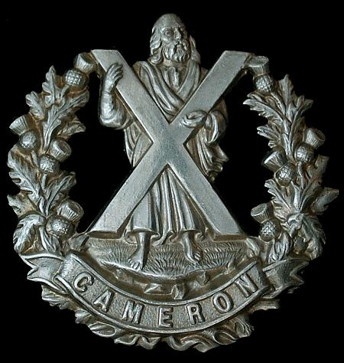
Cameron Highlanders Cap Badge
5th Battalion Cameron Highlanders
Army No: S/12185

Rank: Private
Service No: S/12185
Date of Death: 07/08/1915
Age: 37
Regiment/Service: Cameron Highlanders, 5th Bn.
Grave Reference: VI. E. 6.
Cemetery: PONT-DU-HEM MILITARY CEMETERY, LA GORGUE
Additional Information: Son of William and Mary Brechin, of Glasgow.

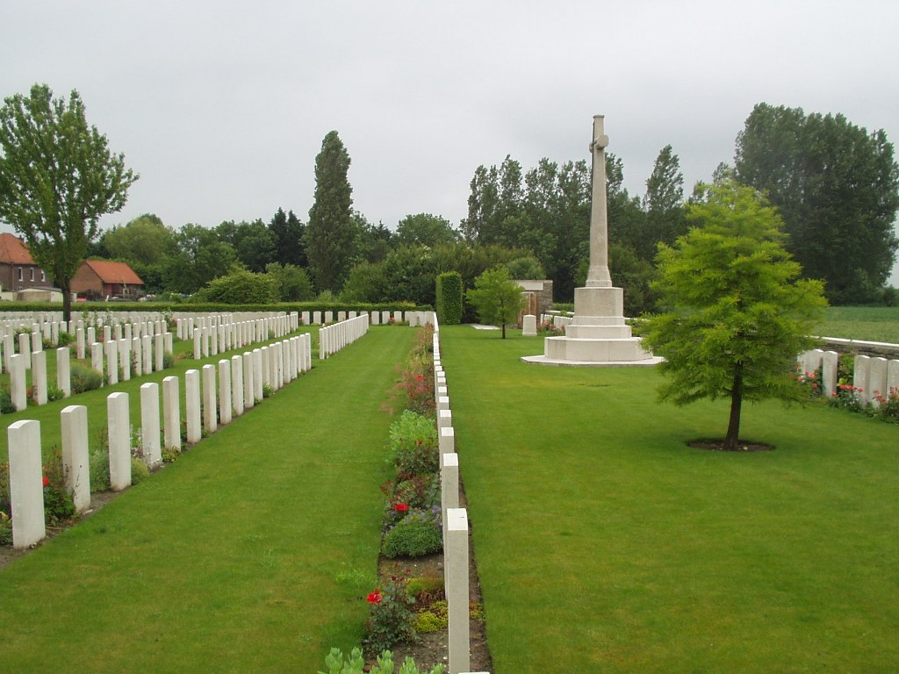
Pont-Du-Hem Military Cemetery, La Gorgue

Country: France

Locality: Nord

Identified Casualties: 812

Location Information
Pont-du-Hem is a hamlet situated on the main road from La Bassee to Estaires. Follow the D947 from La Bassee to Estaires for 10 kms and the cemetery lies on the left hand side of the road, 5 kms short of Estaires.

Historical Information
Pont-du-Hem was in German hands from mid-April to mid-September 1918. The Cemetery was begun, in an apple-orchard, in July 1915, and used until April 1918, by fighting units and Field Ambulances; these original burials are in Plots I, II and III, and Rows A and B of Plot IV. In April and May 1918, German burials were made in Plots III and IV. After the Armistice, 426 German graves were removed to other cemeteries; the Portuguese graves of 1917-1918 were removed to the Portuguese cemetery of Richebourg-L'Avoue; and British graves were brought in from the surrounding battlefields and from smaller burial grounds, including:-

BEAUCAMPS COMMUNAL CEMETERY GERMAN EXTENSION, a cemetery of 1,800 graves: 104 U.K., A.I.F. and N.Z.E.F., 1914-18.

BOUSBECQUE COMMUNAL CEMETERY GERMAN EXTENSION (2,300 Germans): 21 U.K., 2 A.I.F., 1917-18.

COMINES COMMUNAL CEMETERY GERMAN EXTENSION (2,400 Germans): 21 U.K., 1 Canadian, 1 A.I.F., 1 N.Z.E.F., 1915-17.

DEVASIER FARM GERMAN CEMETERY, WAMBRECHIES, on road to Quesnoy-sur-Deule (1,500 Germans): 19 U.K., 1916-18.

EDWARD ROAD CEMETERY No.3 (WINDY CORNER), RICHEBOURG-L'AVOUE: 12 U.K., 1914-15.

ENNEQUIN COMMUNAL CEMETERY GERMAN EXTENSION, LOOS (near Lille): 977 Germans, 9 U.K., 2 A.I.F., 1917-18.

ESTAIRES CONVENT CEMETERIES No.1 and No.2, made by the Germans, on the North side of town: 4 U.K., 1918.

FERME DELOUX-BOQUET, NOUVEAUMONDE, La GORGUE: 17 U.K., 1 A.I.F., 1915-16.

FESTUBERT NORTH CEMETERY, on North-West side of village: 20 U.K. and 5 Canadian, 1915-16.

HALLUIN COMMUNAL CEMETERY GERMAN EXTENSION (2,216 Germans): 36 U.K., 3 Canadian, 1 N.Z.E.F., 1917-18.

INDIAN VILLAGE GRAVEYARDS No.1 and No.2, RICHEBOURG-L'AVOUE and FESTUBERT, North of Rue de Cailloux: 39 U.K. and 1 Canadian, May-Sept., 1915.

LA CORDONNERIE FARM CEMETERY, North of FROMELLES: 58 of the 2nd R.W.F., Oct.-Nov. 1914.

LACOUTURE CHURCHYARD: 1 R.F.A., Oct. 1914.

LA FOSSE GERMAN CEMETERY, in a chateau garden South of LESTREM: 6 U.K., 1918.

LAVENTIE NORTH GERMAN CEMETERY, near the railway station.

LE TROU-BAYARD GERMAN CEMETERY, ESTAIRES: 36 U.K. (mainly 50th Div.) and 2 A.F.C., April-Nov. 1918.

LOCON CHURCHYARD: 1 U.K., Nov. 1914.

RUE MASSELOT GERMAN CEMETERY (made round the British Cemetery, and called by the Germans WANGERIE): 8 U.K. and 1 Italian, 1918.

VERLINGHEM GERMAN CEMETERY, on South-West outskirts of village (1,152 Germans): 14 U.K. and 1 A.I.F., 1916-17.

VIEILLE-CHAPELLE CHURCHYARD: 14 U.K., 1914-15.

There are now over 1,500, 1914-18 war casualties commemorated in this site. Of these, over half are unidentified and special memorials are erected to nine soldiers from the United Kingdom believed to be buried among them. Other special memorials record the names of 44 soldiers from the United Kingdom, two from Canada, two from Australia and one of the Royal Guernsey Light Infantry, buried in this or other cemeteries, whose graves were destroyed by shell fire, and of five Indian soldiers whose bodies were cremated. There are 107 German burials and 1 American.

The cemetery covers an area of 6,433 square metres.

The 1901 census shows the following information:
William was residing at 2 Bruce Road, Kinning Park, Glasgow with his father William Brechin aged 58 and a butcher. His mother was called Mary and she was 52 years of age. William’s eldest brother was called Thomas A Brechin aged 27 and a Butcher Shopman to trade. His eldest sister was called Euphemia M Brechin aged 25 and no employment was listed, next was William and he was 23 years and his employment was as a clerk, (stock brokers). The next brother was John A Brechin aged 21 and a flesher’s shop man. Hugh Brechin aged 19 came next and he was an Apprentice Accountant. Mary A Brechin was the second youngest sister aged 15, who was living in the house and she was listed as a scholar. Last of the siblings was Janet I A Brechin aged 12 and she also was listed as a scholar.

With such a large family it is not surprising that they had two domestic servants, the oldest was Mary A Murray, aged 21 years and the second was Margaret F Mci Green aged 16.

